**KAMPALA PARENTS’ SCHOOL 2004**

**END OF YEAR EXAMINATION, 2018**

**LITERACY 1A- P.1**

Time: 2hrs 15 min

**NAME: _________________________AD.NO._______STREAM:____**

**DATE: _________________**

1. Fill in the missing letters

**a**.g___lls **b**. sn__ke **c**. n___st

1. 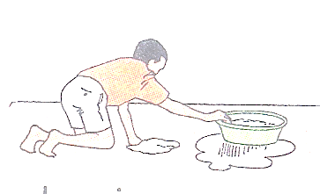We keep the school clean by

|  |  |
| --- | --- |
|  | ____________________the floor. |
|  | ____________________ the compound. |
|  | ___________________ the tall grass. |

1. Why should we keep the school clean? Give one reason.

To prevent _______________________________________________________

1. Name any two things found in a dirty home.

________________________________and ______________________________

1. Draw and name any two domestic animals.

|  |  |
| --- | --- |
|  |  |
|  |  |

1. Match correctly

cow kennel

pig shed

dog hutch

rabbit kraal

goat pigsty

1. 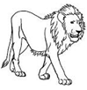 This is a lion.

Why does it make sound?

When it is _____________________________________

1. 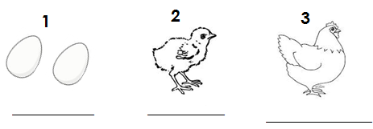Name the stages of growth of a hen.
2. A hen takes __________days to hutch its eggs.
3. 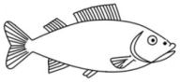 This is a ___________________________________________

Its young one is called a ___________________________

It moves by _____________________________________________________

1. 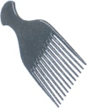Name these things people use to clean the body.

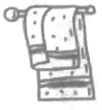

______________________ ______________________

1. Draw and name the body parts that do the following

|  |  |
| --- | --- |
|  |  |
| **Walking** | **seeing** |

1. Give any one danger of a dirty home.

___________________________________________________________________

1. Mention any two body exercises.

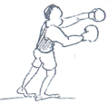_________________________________and_________________________________

1. This boy does exercises every day. Why?

To _________________________________________________

1. Give any two examples of non-living things

_________________________________and_________________________________

1. 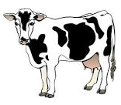 This is a _____________________________________________

Why is it called a living thing?

________________________________________________________________

1. Tick any two wastes from our body.

**sweets urine legs faeces soap**

1. Draw and name any one fruit that we eat.

______________________________________________

1. Match correctly

cassava plant stem

cabbage plant fruit

sugarcane plant roots

apple plant leaves

1. Tick (√ ) the good eating habbits.
2. Praying before eating
3. singing as you eat food.
4. wash your hands before and after eating.
5. playing while eating.
6. 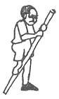 This boy is suffering from ________________________________.
7. Sharp objects that cause accidents. Match them.

|  |  |
| --- | --- |
|  | nails |
|  | razorblade |
|  | knife |
|  | safety pin |

**Merry Christmas & Happy New Year 2019**